**Displaying the motor status on LCD using Arduino UNO**

Description:

In this project we will be displaying the status of a DC Motor on a Liquid Crystal Display. It consists of a Microcontroller (Arduino UNO), LCD 16X2, Motor, Push button. The LCD is connected to Arduino through digital pins (D2-D5, D11, D12), DC motor is connected to digital pin (D1) and the Push button is connected to an analog pin (A5). The motor can be turned ON and OFF using the push button and the respective result is displayed on the LCD. When the push button is pressed, the Arduino reads the input and sends a signal to the motor to turn ON and at the same time LCD display the status of the DC motor as ‘ON’. When the push button is again pressed the DC motor is turned OFF and the LCD display the status of the DC motor as ‘OFF’.

Block diagram:

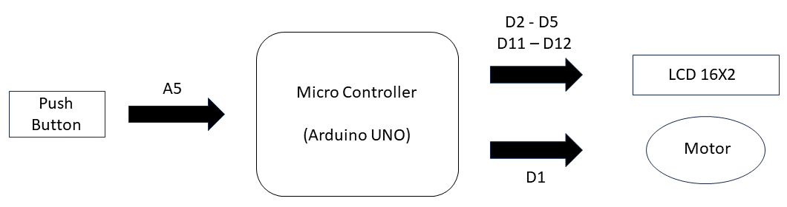

Input and Output:

|  |  |  |  |  |  |  |
| --- | --- | --- | --- | --- | --- | --- |
| **Sl.no** | **Description** | **Name** | **Type** | **Data Direction** | **Spectification** | **Remarks** |
| 1 | Button Pin | PB1 | INP | D1 | Digital | Active High |
| 2 | LCD RST | RS | OUT | DO | Digital | Active High |
| 3 | LCD EN | EN | OUT | DO | Digital | Active High |
| 4 | LCD DATA PIN | D4 | OUT | DO | Digital | Active High |
| 5 | LCD DATA PIN | D5 | OUT | DO | Digital | Active High |
| 6 | LCD DATA PIN | D6 | OUT | D0 | Digital | Active High |
| 7 | LCD DATA PIN | D7 | OUT | DO | Digital | Active High |
| 8 | Motor | PD1 | OUT | AO | Analog | Active High |

Souce Code :

#include <LiquidCrystal.h>

const int rs = 12, en = 11, d4 = 5, d5 = 4, d6 = 3, d7 = 2;

LiquidCrystal lcd(rs, en, d4, d5, d6, d7);

const int buttonPin = A5;

const int motorPin = 1;

int motorState = 0;

int lastButtonState = HIGH;

int buttonState;

void setup() {

lcd.begin(16, 2);

pinMode(buttonPin, INPUT);

analogWrite(motorPin, motorState);

updateLCD();

}

void loop() {

buttonState = digitalRead(buttonPin);

if (buttonState != lastButtonState) {

if (buttonState == LOW) {

motorState = 255 - motorState;

analogWrite(motorPin, motorState);

updateLCD();

}

}

lastButtonState = buttonState;

}

void updateLCD() {

lcd.clear();

lcd.setCursor(0, 0);

lcd.print("Motor: ");

if (motorState == 0) {

lcd.print("OFF");

} else {

lcd.print("ON");

}

}

**Schematic:**

